**Buy & Sell Gold**

Overview

Your task is to buy and sell gold with one advantage - you know how the price varies over time. In the sections below you will first be presented with a description of the problem you have to solve. Then, you will be taken through the API available for you to solve the problems. Following that will be an explanation of how scores are calculated.

*Make sure to read the entire description before attempting the problem*

Task Description

Each level will have a different price variance and a different number of days. Using the provided data, you must buy gold once and sell gold once in order to achieve maximum profit. You always buy the same amount of gold, so the trick is to gain as much profit as possible for this static amount. You are not allowed to buy and sell on the same day. If you cannot achieve a profit - achieve a minimum loss.

You can access the data by using the API functions found under the API tab. The API is described more in detail in the API Description section.

Canvas Description

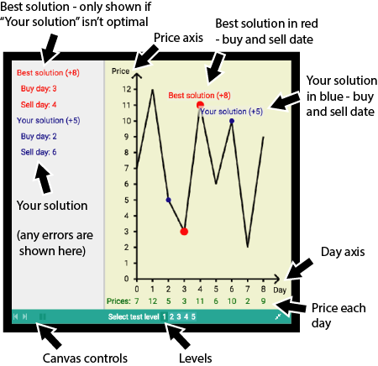

API Description

The following data is available for you to access through the API provided. Details about the API functions and the data they provide can be found under the API tab.

1. Number of Days

* The total number of days of data (i.e. number of days for which data is available) that are available to you for the given level.

1. Price on day

* The price of gold on the given day.

Scoring

Focus on getting the correct output, as this is the major part of the scoring (80%). You can see your points for each level in the canvas on the bottom right when you press Run code. *Note that your code will be assessed using hidden levels of different configurations. Ensure your code works for all scenarios.*

20% of your score is calculated through time-complexity analysis of your solution, so if you have time try to consider how to make your solution as efficient as possible